R. Delord – Latine Loquere

- Paroles de chansons traduites en latin : The Cure, Friday I'm in love -
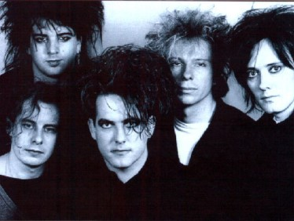

Non curo si dies Lunae caerulus est
Dies Martis gratus est,
Et dies Mercurii quoque
Dies Iovis, non curo de te,
Sed die Veneris, adamo.

Dies Lunae, potes diffringere.
Dies Martis Mercuriique cordem meum frangunt,
Dies Iovis non incipit,
Sed die Veneris adamo.

Dies Saturni expectat,
Dies Solus semper nimis serius venit.

Non curo si Dies Lunae niger est.
Dies Martis Mercuriique, infarctio cordis,
Dies Iovis numquam retrospectat,
Sed die Veneris adamo.

I don't care if Monday's blue
Tuesday's grey and Wednesday too
Thursday I don't care about you
It's Friday, I'm in love
Monday you can fall apart
Tuesday, Wednesday break my heart
Oh, Thursday doesn't even start
It's Friday I'm in love
Saturday, wait
And Sunday always comes too late
[But Friday, never hesitate...]
I don't care if Mondays black
Tuesday, Wednesday - heart attack
Thursday, never looking back
It's Friday, I'm in love

The Cure

http://www.ac-grenoble.fr/lycee/diois/Latin/index.html

